Printing Hello world
Workshop #1
Flutter Developer Bootcamp

Purpose
This workshop demonstrates likely to introduce participants to the Dart programming language, focusing on its syntax, basic operations, and running simple programs.

Problem
In the given workshop demonstrates a basic "Hello, World!" program. It starts with the main function, defined as void main(List<String> args), which serves as the entry point of the application and can optionally accept command-line arguments. Inside the main function, print('Hello world'); outputs the string to the console. This simple example introduces Dart's basic syntax and structure, showcasing function definition, potential command-line input handling, and console output. It's an ideal starting point for setting up a Dart development environment and practicing basic Dart programming.

How to Solve
- Checkout the workshop from Git Repo:
git clone -b <user-branch> <repo-URL>
- Open the root folder inside VS Code
- Open the root folder in terminal
- Run the command dart run filename.dart
- Program Start:
- When the Dart program is executed, the Dart runtime looks for the main function and starts execution from there.
- Print Statement Execution:
- The print('Hello world'); statement is executed, which outputs the string Hello world to the console.
- Go To File: <specific-file--method> à <method-name>, implement your logic.

You will Achieve
When you complete this workshop you will learn the following:
Methods and Functions Included:

- main Function:
- Syntax: void main(List<String> args)
- Purpose: Serves as the entry point of the Dart application. It can accept a list of command-line arguments.

- print Function:
- Syntax: print(Object object)
- Purpose: Outputs text or objects to the console. In this case, it is used to print the string 'Hello world'.

Screenshots

Before implementation (without printing hello world)

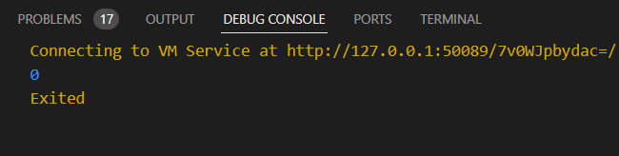

After implementation (with printing hello world)

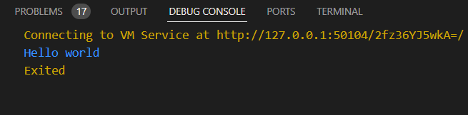

How to submit your workshop
Push your project back to the same git branch using command:
<command name>

Happy Coding!

